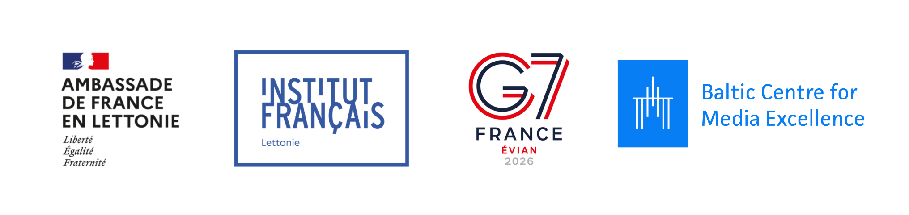
Baltic Shield: Strengthening Independent Media
Application Form
Please complete this form to apply for participation in the Baltic Shield: Strengthening Independent Media.
The information provided will help us assess your outlet’s needs and match you with suitable mentors or project opportunities.

1. Organisation Information
Name of media outlet: _________________________________________________________
Website: ____________________________________________________________________
Country of registration: _______________________________________________________
Contact person (name, position, email): __________________________________________
____________________________________________________________________________
A short description of your media outlet
Please briefly describe your mission, target audience,
editorial focus, languages of publication.
(maximum 150 words)
Number of employees
Full time | Freelancers
Which best describes your organisation?
☐ National media
☐ Regional media
☐ Exile media

2. Current Situation
Which of the following challenges are currently relevant?

☐ Cybersecurity
☐ Secure communications
☐ Crisis response planning
☐ FIMI preparedness
☐ Editorial workflows
☐ Data security and backups
☐ AI policy
☐ AI verification
☐ Other: ____________________________________________________________________

Main Challenges
Please describe the key challenges your outlet faces in questions of cybersecurity, digital security, data management, crisis management and communication planning.
(maximum 300 words)
3. Mentorship Request

What would you like to improve through this programme?
Please describe what you would like to focus on during your mentorship.
(maximum 300 words)

Why is this important for your organisation now?

Please describe the urgency of your request.
(maximum 200 words)

What outcomes would you like to achieve?
☐ Resilience plan
☐ Security protocol
☐ AI policy
☐ Improved workflows
☐ Staff training
☐ Implementation of new tools
☐ Other: ____________________________________________________________________

How do you expect to use the implementation grant (EUR 1,800)?
Examples: software, hardware, subscriptions, AI tools.

(maximum 200 words)

Please submit the completed application form by
23:59 EET July 31, 2026 to aya.jakimova-kuge@bcme.eu.
If you have questions, contact aya.jakimova-kuge@bcme.eu.

